COMPANY NAME OIL SERVICES LTD.

NEMBE SOUTH G3 WELL SITE

MANAGEMENT FACILITY INSPECTION (MFI) REPORT

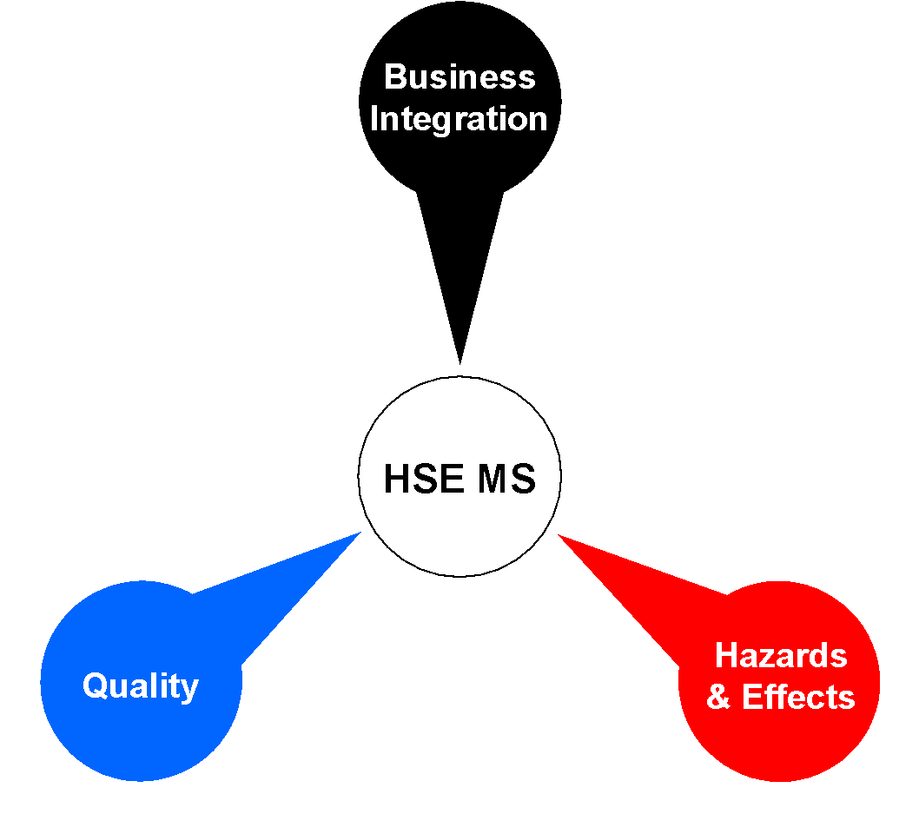

MFI VISIT TO WELL SITE (NEMBE SOUTH 3G WELL SITE)

WEDNESDAY JANUARY 9TH, 2019.

Management Inspection Team

(Team Lead) - Head, COMPANY NAME HWU / RIG Operations Mgr

- COMPANY NAME HWQ Operations Superintendent

– COMPANY NAME HWO Project HSSE Manager

- COMPANY NAME HWU RIG Supervisor

- COMPANY NAME HWU RIG Supervisor

- NAOC DSV

– COMPANY NAME Rig Medic

Rig HSSE Officer for Nnembe South G3

- COMPANY NAME Barge Master –JJ HENRY HWU

Summary
As a continuous drive for the field workforce concern and a keen demonstration of management commitment to HSSE, the COMPANY NAME HWU/Rig Operational Head of department HSE, Engr Irenus Emeruem in compliance with 2019 HSE Plan, carried out an MFI on the Obama flow station Marine incident where some personnel’s were drowned on the water Quay at the Obama area.
This incident investigative MFI visit objective was to check and sensitize personnel’s compliance to company policies and enforce the rules and regulations on the location; as an aftermath of the Marine incident on Friday 4th January 2019. The team arrived the Akepilar Water Jetty and made efforts to communicate the Rig team to send an official speed boat at about 14:45 it took about an hour (As a result of poor network at the Rig site) to get the boat from the rig to pick the team from the Akepillar jetty pm.
On arrival to the rig site, we stopped over at the recreation to wait the DSV for a brief safety induction and introduce the aim of the visit. The HSE induction was done by Michael Barango, the Rig HSE coordinator after which the visiting team addressed the crew before the carried out investigation on the marine incident and a general inspection of the rig site equipment and on-going operations.

A total of 11 lowlight observations were generated with appropriate recommendations given for immediate close out. Risks ranking of findings are as follows: 4 medium risk ranking and 2 low risk ranking as detailed in the table of actions.
Highlights:
1. Crew in high spirit and correct PPEs despite sad incidence.
2. MFI team properly inducted by personnel on board.
3. MFI team interacts with NAOC, COMPANY NAME and Genesis team on board on implementation of company policies as regards journey management and authorization, use of PDFs and camp rules as regards leaving location.
4. Reactions from NAOC DSV, NAOC safety, Genesis camp boss and COMPANY NAME supervisors on the incident. As well as appreciating vote of thanks from COMPANY NAME supervisors and the NAOC DSV.

6. Tour of the accommodation cabins to see state of facilities

Lowlights
1. There was very poor GSM Network and no communication means on the location. It took the visiting team 1 hr. to reach out to location to send a boat to AkepiIla jetty.
2. Observed the HWU JJ Henry 340k Unit does not have a HAC diagram and a noise map
3. The creek route to the location is covered by water hyacinth making it difficult for boats to navigate.
4. The House Boat accommodations is not enough for POB. Personnel were observed sleeping on the floor and inside the recreation.
5. Some rooms in one of the houseboats have blocked plumbing making the room restrooms unusable.
6. No adequate muster barge on location for POB in case of Emergency evacuation.

7. The HSSE induction was not robust as visual slides not used during induction.
8. Army personnel on board are not inducted.
9. Emergency Alarm blaring types was not mentioned during inductions and T-card system not being enforced yet.
10. No clearly indicated smoking area yet.
11. Poor access control/checks into the location

Below are some further observations/recommendations/action points from the inspection:
S/N | OBSERVATION | RECOMMENDATION/ACTION POINT | Risk Rating | ACTION PARTY | TARGET DATE
 | There was poor GSM Network and no communication means on location. It took the visiting team 1 hr. to reach out to location to send a boat to Akepila jetty. | The NAOC Dsv was told to escalate communication problem to town and ensure a reliable communication is established before full commencement of operation. | H | NAOC DSV | Immediate
 | Observed the HWU JJ Henry 340k Unit does not have a HAC diagram and a noise map | A HAC diagram should be generated to educate crew on the hazardous Area of the operation. | L | COMPANY NAME HSSE | Immediate
 | The creek route to the location is covered by water hyacinth making it difficult for boats to navigate. | NAOC to be informed to clear water hyacinth from route to make it easier for boats to navigate. | M | NAOC CLO | Immediate
 | The house boat accommodations not enough for POB. Personnel were observed sleeping on the floor and inside the recreation | An additional or alternate accommodation to be discussed, concluded in town and provided for personnel ASAP. | H | COMPANY NAME/NAOC Mgt | Immediate
 | No adequate muster barge on location for POB to converge in case of Emergency evacuation. | COMPANY NAME and NAOC office team to discuss on possibility of getting a dedicated muster barge on location. | M | COMPANY NAME/NAOC Mgt | Immediate
 | Some rooms in one of the houseboats have blocked plumbing making the room restrooms unusable. | House boat owners need to be contacted to find solution to the plumbing problem | M | COMPANY NAME Marine Team | Immediate
 | The HSSE induction was not robust as visual slides was not used during induction | Visual ppt slides to be used during the induction of personnel and ensure every personnel signs after the induction. | L | HSSE Officer | Immediate
 | Army personnel on board are not given safety inducted on arrival | The Army personnel need to be inducted in their houseboat anytime they arrive on board. | M | HSSE Officer | Immediate
 | Emergency Alarm blaring types was not mentioned during inductions and T-card system not being enforced yet. | Emergency Alarm blaring types need to be mentioned during safety inductions and T-card system need to be enforced. | L | HSSE Officer | Immediate
 | No clear indicated smoking area yet. | A designated smoking area to be properly marked | M | HSSE Officer/Rig Supv | Immediate
 | Poor access control/checks into the location |  | M | HSSE Officer/Rig Supv | Immediate

The inspection ended at about 15:30hrs with a debrief session by the inspection team. A debrief was given to the DSV, ADSV and the crew and they promised to close-out all actions with the support of drilling contractor and town HSSE support. A total of Eleven (11) key areas for improvement were highlighted during the visit. The crew members expressed their gratitude to the team lead for making out time to be with them and promised to work safe at all times.

