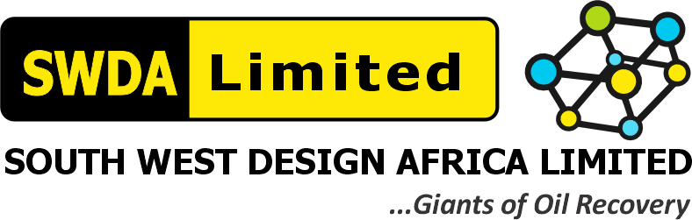
SOUTH WEST DESIGN AFRICA LIMITED (SWDA)
RAEC 18-TANK ATC/NME TANK CLEANING PROJECT — Contract/Tender No. CW-68582 / CW-515913
SWDA CHEMICAL MANAGEMENT PROCEDURE
With Applied Hierarchy of Control Measures
RAEC Capability Assessment Reference | Item 5.4(d)-3 — "What process covers performance of chemical risk (and substitution) assessments, to implement necessary mitigating measures and to confirm relevant permit/license from public authorities?"
Requested Evidence | SWDA Chemical Mgmt. Procedures, with Hierarchy of Control Measures, endorsed by MD
Assigned To | Miracle Maduforo (Project Manager — Field Supervisor)
Document Date | 06 August 2026

This procedure sets out how SWDA manages chemical risk across the tank-cleaning project lifecycle — procurement through disposal — and applies the Hierarchy of Controls to the chemicals identified in the companion MSDS/SHOC register (Item 5.2(e)-4 / 5.4(d)-2).

1.0 Purpose & Scope
To ensure all chemicals used, stored, transported or disposed of on SWDA tank-cleaning projects (crude oil/gas oil diluent, detergent, nitrogen, and any process-residual H₂S encountered) are managed to keep chemical risk As Low As Reasonably Practicable (ALARP), consistent with the SWDA – RAEC HSE Plan's Environmental Risk provisions and Occupational Health Policy.

2.0 Chemical Management Procedure
2.1 Procurement & Substitution Review
- Before any new chemical is introduced to a project, the Site Safety Manager reviews whether a less hazardous substitute is available (Chemical Alternatives Assessment).
- Only chemicals with a current manufacturer Safety Data Sheet (SDS) on file are approved for site use.
2.2 Inventory & Tracking
- A centralized Chemical Inventory Register is maintained at the Lagos base office and mirrored at each site, recording chemical name, quantity held, location, and SDS reference.
- Daily/weekly usage quantities are logged against the inventory for each active task (e.g., ATC diluent consumption, nitrogen cylinder usage).
2.3 Storage
- Flammable/hazardous chemicals (crude oil, gas oil) are held in bunded storage, segregated from incompatible materials and ignition sources.
- Compressed gases (nitrogen) are secured, leak-checked, and stored upright with valve protection in place.
2.4 Handling & Use
- All chemical handling tasks require a Permit to Work and, where applicable, a completed SHOC Card review before work begins.
- PPE specified on the relevant SHOC Card (gloves, goggles, ATEX equipment, gas detectors) is mandatory and verified by the On-Site HSE Officer before task start.
2.5 Transport
- Chemicals are transported in approved, correctly labelled containers on vehicles meeting SWDA's Moving Plant & Equipment controls (speed limits, licensed drivers, approved vehicles).
2.6 Spill Response & Disposal
- Oil Spill Kits and Chemical Spill Kits are positioned at all active work areas; any spill triggers the Environmental Risk response under the HSE Plan.
- Waste chemicals and contaminated materials are classified, labelled, and disposed of through SWDA's Waste Management Plan (WMP), in line with NESREA/NOSDRA requirements.
2.7 Review
- The Chemical Inventory and this Procedure are reviewed annually, at each project mobilization, and whenever a new chemical is proposed for use.

3.0 Hierarchy of Control Measures — Applied to SWDA's Likely Chemicals
Per accepted HSE practice (and consistent with the HSE Plan's approach to Risk Controls in Section 3.3), SWDA applies controls in the following order of preference: Elimination → Substitution → Engineering Controls → Administrative Controls → Personal Protective Equipment (PPE), used in combination where a single level does not sufficiently reduce risk.
Control Level | Description | Applied Example
1. Elimination | Remove the hazardous chemical/task entirely where possible | Automatic Tank Cleaning (ATC) is employed specifically to eliminate the need for manual entry/contact with tank contents wherever the tank condition allows
2. Substitution | Replace with a less hazardous substance or method | Use of lower-toxicity detergents where technically acceptable for cleaning performance
3. Engineering Controls | Isolate people from the hazard through equipment/design | Tank purged and held under inert nitrogen atmosphere with automatic O₂ shutdown above 8%; ATEX-rated pumps and bonded hosing for diluent transfer; fixed and personal H₂S/O₂ monitors with automatic alarms
4. Administrative Controls | Procedures, permits, training and scheduling that reduce exposure | Permit to Work system; SHOC Card sign-off before task start; CSE entry only during daylight hours (out-of-hours by exception); rotation of entry personnel to prevent exhaustion; toolbox talks before chemical-handling tasks
5. PPE | Personal protective equipment as the last line of defence | Chemical-resistant gloves, coveralls, safety glasses/goggles, SCBA/Escape Sets, 4-Gas Detectors per the relevant SHOC Card
This hierarchy is applied and documented on the Risk Assessment for every chemical-handling task before work is authorized — consistent with the RAM methodology in Section 5.1(g) of this evidence set (Safety & Control Systems / ALARP).

4.0 MD Endorsement
I, Gliffeth Wonuigwe, Group CEO / Managing Director of South West Design Africa Limited (SWDA), endorse the Chemical Management Procedure and Hierarchy of Control Measures set out above as SWDA's operative approach to chemical risk management.
SIGNED: ______________________________
Gliffeth Wonuigwe — Group CEO / Managing Director, SWDA Limited
Date: 06 August 2026

