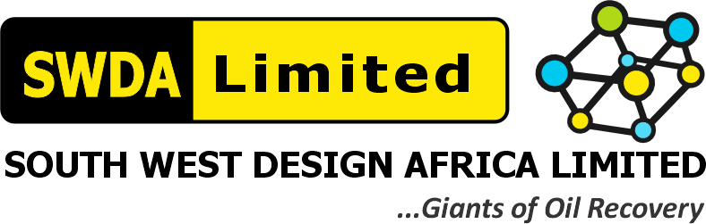
SOUTH WEST DESIGN AFRICA LIMITED (SWDA)
RAEC 18-TANK ATC/NME TANK CLEANING PROJECT — Contract/Tender No. CW-68582 / CW-515913
LIKELY CHEMICALS REGISTER — MSDS SUMMARY & SHOC CARD
Tank Cleaning Operations — Chemicals Identified in HSE Plan Attachment 1 (JHSA)
RAEC Capability Assessment Reference | Item 5.2(e)-4 / 5.4(d)-2 — "How does the contractor evaluate the health risks presented by use, transport and disposal of chemicals?"
Requested Evidence | Appropriate SWDA Likely Chemicals MSDSs & SHOC Cards, endorsed by MD
Assigned To | Miracle Maduforo (Project Manager — Field Supervisor)
Document Date | 06 August 2026

This register lists the chemicals/substances likely encountered on SWDA's tank-cleaning campaigns, drawn directly from the hazards already identified in Attachment 1 (JHSA) of the SWDA – RAEC HSE Plan, together with an MSDS summary and a Safe Handling of Chemicals (SHOC) Card for the highest-volume substance.

1.0 Likely Chemicals Register — MSDS Summary
Chemical / Substance | Hazard Class | Key Health/Safety Hazards | Required PPE | Storage / First Aid
Crude Oil / Gas Oil (Tank Cleaning Diluent) | Flammable Liquid; Irritant; Suspected Carcinogen (long-term exposure) | Skin/eye irritation; inhalation of vapours; flammability near ignition sources | Chemical-resistant gloves, coveralls, safety glasses/goggles; ATEX equipment when handling | Bunded storage away from ignition sources; eye wash if splashed; remove contaminated clothing
Detergent (Tank Cleaning Agent) | Irritant | Skin/eye irritation on contact | Gloves, safety glasses, coveralls for routine handling | Store per manufacturer SDS; flush with water if contact occurs
Nitrogen (N₂) — Tank Inerting / Purging | Asphyxiant (simple, non-toxic but displaces oxygen) | Asphyxiation risk in confined/poorly-ventilated spaces; no odour warning | 4-Gas Detector (O₂ monitoring), SCBA/Escape Set for CSE work under nitrogen atmosphere | Cylinders/lines secured and leak-checked; evacuate immediately on low-O₂ alarm; move to fresh air
Hydrogen Sulfide (H₂S) — Potential Process Residual | Toxic Gas; Asphyxiant | Fatal at high concentration; odour fatigue at low levels | Personal H₂S monitors (mandatory), Breathing Apparatus (SCBA) on alarm | Fixed H₂S monitors/alarms at work area; evacuate on activation; move casualty to fresh air, administer O₂ if trained
Full manufacturer Safety Data Sheets (SDS) for each substance are held in SWDA's Chemical Inventory file at the Lagos base office and site HSE offices, and are available to Renaissance/RAEC on request.

2.0 Sample SHOC (Safe Handling of Chemicals) Card
Chemical | Crude Oil / Gas Oil — Tank Cleaning Diluent
Used For | Automatic Tank Cleaning (ATC) dilution/transfer during tank-cleaning operations
Physical Form | Liquid — flammable
Primary Hazards | Flammable; skin/eye irritant; harmful if inhaled in vapour form; environmental hazard if spilled
Required PPE | Chemical-resistant gloves, coveralls, safety glasses, ATEX-rated equipment where sparks/static are possible
Handling Precautions | Handle only under Permit to Work; use ATEX pump for transfer; bonded hosing; cordon off works area; no ignition sources nearby; O₂/LEL monitoring where entry is required
Storage | Bunded storage area; away from ignition sources and incompatible materials; SDS available at point of storage
Spill Response | Use Oil Spill Kit immediately; contain with absorbent material; do not wash into drains; report per Environmental Policy
First Aid — Skin Contact | Remove contaminated clothing; wash affected area thoroughly with soap and water
First Aid — Eye Contact | Flush immediately with eyewash for at least 15 minutes; seek medical attention
First Aid — Inhalation | Move to fresh air immediately; seek medical attention if symptoms persist
Emergency Contact | Site HSE Officer; SWDA Emergency Response Contacts (see Section 5.1(g) Safety & Control Systems pack)

3.0 MD Endorsement
I, Gliffeth Wonuigwe, Group CEO / Managing Director of South West Design Africa Limited (SWDA), endorse the Likely Chemicals Register, MSDS Summary and SHOC Card set out above as accurate for SWDA's tank-cleaning operations.
SIGNED: ______________________________
Gliffeth Wonuigwe — Group CEO / Managing Director, SWDA Limited
Date: 06 August 2026

