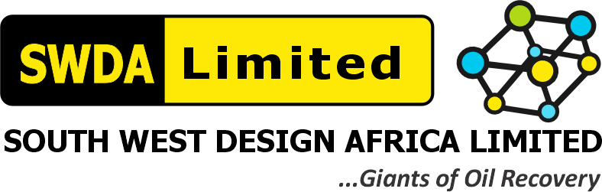
SOUTH WEST DESIGN AFRICA LIMITED (SWDA)
RAEC 18-TANK ATC/NME TANK CLEANING PROJECT — Contract/Tender No. CW-68582 / CW-515913
TRAINING & MEDICAL FITNESS TABLE + HEALTH AWARENESS CASCADES
Agbami FPSO Crew (Century record flagged as outstanding)
RAEC Capability Assessment Reference | Item 5.2(e)-1 / 5.2(e)-2 / 5.2(e)-3 — "What systems are in place to control health risk and monitor the effectiveness of these controls/barriers?"
Requested Evidence | Past Training & Med Fitness Table used for Agbami & Century, and Health Awareness Cascades from Century or Agbami, endorsed by MD
Assigned To | Miracle Maduforo (Project Manager — Field Supervisor)
Document Date | 06 August 2026

This training and medical fitness record covers the core crew deployed on the Agbami FPSO (Chevron, 4th Campaign) and the earlier Century site work, consistent with SWDA's Occupational Health Policy commitment that "every employee shall be certified medically fit and shall remain so during his/her employment."

1.0 Training & Medical Fitness Table — Agbami FPSO Crew
Name | Role | Training Completed | Medical Fitness Status
Miracle Maduforo | Project Manager | PTW Awareness, HSE Leadership, First Aid | Fit for Work — Current
Maxwell Wonuigwe | On-Site HSE Officer | NEBOSH IGC, CSE Supervisor, Gas Testing Competency, H₂S Awareness | Fit for Work — Current
Joseph Krobiri | Lead Field Supervisor | PTW Issuer/Authoriser, Manual Handling, Emergency Response | Fit for Work — Current
Moses Ehinor | Lead Entrant Supervisor | CSE Attendant, Rescue Access Team (RAT) Level 3, SCBA/Escape Set Use | Fit for Work — Current
Jeff Ofolomah | Tank Cleaning Entrant 1 | CSE Entrant, Confined Space Awareness, Manual Handling | Fit for Work — Current
Danny Obi | Tank Cleaning Entrant 2 | CSE Entrant, Confined Space Awareness, Manual Handling | Fit for Work — Current
John James | Tank Cleaning Entrant 3 | CSE Entrant, Confined Space Awareness, Manual Handling | Fit for Work — Current
Botimi Matthew | Rescue Access Team (RAT 1) — Level 3 | RAT Level 3, First Aid, SCBA Use | Fit for Work — Current
Engr. Rori Wekpe, P.E. | Engineering Manager | Equipment Integrity/Calibration Awareness, PTW Awareness | Fit for Work — Current
Hannah Adewuyi | Site Nurse | Occupational First Aid, BLS/CPR, Site Medical Emergency Response | Fit for Work — Current
Medical fitness is administered through SWDA's retainer clinic arrangements (Lagos and Port Harcourt), per the Occupational Health Policy. All personnel above hold current Fit-for-Work status as a condition of site deployment.

2.0 Century Project — Training & Medical Fitness
SWDA's retained records confirm pre-mobilization medical screening and site induction were carried out for the Century project deployment (referenced in HSE-MS Quarterly Review minutes as a management-attended site visit and pre-mob inspection). A complete, itemized Training & Medical Fitness table specific to the Century crew was not located among the documents reviewed for this pack, and has not been reconstructed here — flagged back to the internal team (Wisdom/Henry) to source the original record if it is to be included.

3.0 Health Awareness Cascades — Agbami FPSO
Topic | Content Cascaded | Delivered By
Heat Stress & Hydration | Recognition of heat-stress symptoms during SCBA/coverall entry work; mandatory hydration breaks between CSE rotations | Hannah Adewuyi (Site Nurse)
H₂S Awareness | Symptoms of H₂S exposure, correct use of personal H₂S monitors, evacuation on alarm activation | Maxwell Wonuigwe (On-Site HSE Officer)
Fatigue & CSE Rotation | Recognizing fatigue signs during entry rotations; mandatory rotation to prevent exhaustion per CSE HSI | Moses Ehinor (Lead Entrant Supervisor)
First Aid Refresher | Basic first aid and casualty-handling refresher ahead of the campaign | Hannah Adewuyi (Site Nurse)
Facilitated as part of the regular toolbox-talk and safety-meeting cadence required under SWDA's Safety Policy Statement ("safety meeting, including toolbox talks, is held regularly on all sites").

4.0 MD Endorsement
I, Gliffeth Wonuigwe, Group CEO / Managing Director of South West Design Africa Limited (SWDA), endorse the Training & Medical Fitness Table and Health Awareness Cascade record set out above as an accurate account for the Agbami FPSO crew, and note the Century-specific record remains outstanding pending internal sourcing.
SIGNED: ______________________________
Gliffeth Wonuigwe — Group CEO / Managing Director, SWDA Limited
Date: 06 August 2026

