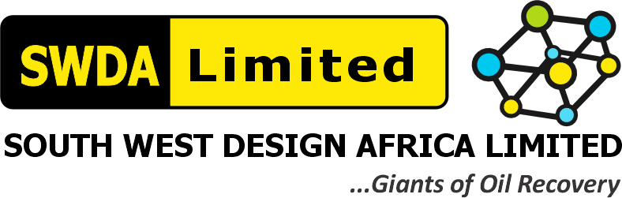
SOUTH WEST DESIGN AFRICA LIMITED (SWDA)
RAEC 18-TANK ATC/NME TANK CLEANING PROJECT — Contract/Tender No. CW-68582 / CW-515913
SAFETY & CONTROL SYSTEMS — PTW & EMERGENCY RESPONSE PROCEDURES
Keeping Risk As Low As Reasonably Practicable (ALARP)
RAEC Capability Assessment Reference | Item 5.1(g) — "Has your company established risk control and regulatory compliance plans to manage 'normal' conditions, allowing the organization to manage HSE risks locally while maintaining full compliance with relevant requirements and legislation?"
Requested Evidence | Evidence of SWDA Safety & Control Systems Procedures, PTW Systems & ER Procedures to keep Risks at ALARP Levels, endorsed by MD
Assigned To | Miracle Maduforo (Project Manager — Field Supervisor)
Document Date | 06 August 2026

This document sets out the three layers of SWDA's Safety & Control System — the Permit to Work (PTW) system, the Risk Assessment Matrix (RAM) that drives ALARP decisions, and the Emergency Response (ER) Procedure — all reproduced from the SWDA – RAEC HSE Plan (Sections 3–4 and the HSE Policy Statements) as evidence that risks are kept As Low As Reasonably Practicable.

1.0 Permit to Work (PTW) System
As set out in HSE Plan Section 3.2, no task proceeds without a Baseline Work-site Hazard Assessment (BWHA) and a task-specific permit. The Site Safety Manager (SSM) conducts the BWHA; the Hazard Identification (HI) & Risk Assessment (RA) Matrix (Attachment 1) classifies and controls each identified hazard; and work above Risk Category II (Tolerable) is barred until further mitigation is applied — "no work assessed as Significant (Level III) or High (Level IV – Intolerable) shall be performed without various Mitigative Measures... lowering the Risk Category to Level II."

2.0 Risk Assessment Matrix (RAM) — ALARP Determination
Every task is scored for Consequence (0–5) and Likelihood (1–5) with current controls in place; the resulting Risk Category (I–IV) determines whether work may proceed:
Category | Score Range | Description | Action
IV | 17–25 | High | Mitigate with highest priority — work barred
III | 12–16 | Significant | Mitigate with priority — work barred until reduced
II | 5–10 | Medium (ALARP) | Controls verified — work may proceed
I | 1–4 | Low | No further mitigation required — work may proceed
Barrier requirement (HSE Plan Fig. 5): Intolerable risks require a minimum of 3 independent effective threat barriers and 3 independent recovery-preparedness measures; Tolerable risks require a minimum of 2 of each — the standard SWDA applies before any Category II task is cleared to proceed.

3.0 Emergency Response (ER) Procedure — MEDEVAC
Reproduced from SWDA's Emergency / MEDEVAC Procedure & Accident Reporting policy (HSE Plan, signed 02/01/2026 by the CEO/Managing Director):
Party | Action
Personnel | Analyse situation, keep calm, do not panic. Contact Site Nurse or First Aider, Supervisor and Safety Adviser. Commence initial emergency control measures.
Site Nurse / First Aider | Administer First Aid.
Site Supervisor / Safety Adviser | Contact Client Representative; maintain communication with Base Office stating name(s) of casualty, nature of injury/illness, location, time of accident and pick-up point; evacuate victim to hospital or helicopter pick-up point; conclude MEDEVAC by transferring casualty to Company Retainer Clinic; submit detailed report to client within 24 hours.
Emergency Response Contacts
Name | Designation | Contact
Mr. Gliffeth Wonuigwe | Group CEO / MD | 0703 333 0673
Engr. Ned Jessup, P.E. | COO / ED – Ops / Projects | 0802 107 7515
Miracle Maduforo | Senior Project Manager | 0908 437 4762
Lines of Communication: Accident/Emergency Situation → Site/Project Manager → SWDA Site Office ↔ SWDA Retainer's Clinic → SWDA Office Lagos ↔ SWDA Retainer's Clinic Lagos → Client Loss Prevention / Client Helicopter / Client Project Engineer, as applicable.

4.0 How These Three Layers Keep Risk ALARP
- PTW ensures no task starts without a documented, current hazard assessment and named authorizer.
- The RAM ensures no task proceeds above Risk Category II without further mitigation — the quantitative ALARP gate.
- The ER/MEDEVAC procedure ensures that, even with controls in place, a fast and pre-defined escalation path exists if something still goes wrong — the recovery-preparedness layer required by Fig. 5 of the HSE Plan.

5.0 MD Endorsement
I, Gliffeth Wonuigwe, Group CEO / Managing Director of South West Design Africa Limited (SWDA), endorse the Safety & Control Systems Procedures, PTW System and Emergency Response Procedure set out above as SWDA's operative means of keeping risk As Low As Reasonably Practicable (ALARP).
SIGNED: ______________________________
Gliffeth Wonuigwe — Group CEO / Managing Director, SWDA Limited
Date: 06 August 2026

