SOUTH WEST DESIGN AFRICA LIMITED (SWDA)

WASTE MANAGEMENT & HOUSEKEEPING
INSPECTION REPORT
SWDA Lagos Office — Waste Bin Photo Evidence & Compliance Assessment
FIELD | DETAIL
Document Title | SWDA Waste Management & Housekeeping Inspection Report — Lagos Office
Document Control No. | SWDA-HSE-WASTE-LAG-001
Location | SWDA Lagos Office — external waste bin storage area
Inspection Basis | Photo evidence submitted for review
Related HSE-MS Reference | Corporate HSE Manual Section 14.0 (Waste Management & Environmental Protection)
Custodian | SWDA Regulatory Compliance Manager (Q-HSE Coordinator)
PREPARED BY: Sonia Somuvie — Regulatory Compliance Manager, SWDA
REVIEWED BY: Maxwell Wonuigwe — On-Site HSE Officer, SWDA
ENDORSED BY: Chief Executive Officer / Managing Director, South West Design Africa Limited

1.0 Purpose
This report records photo evidence of waste bin arrangements at the SWDA Lagos Office and assesses them against the waste management and housekeeping standards in Corporate HSE Manual Section 14.0 (Waste Management & Environmental Protection).

2.0 Photo Evidence

Photo 1 — External Wheelie Bins (x3)
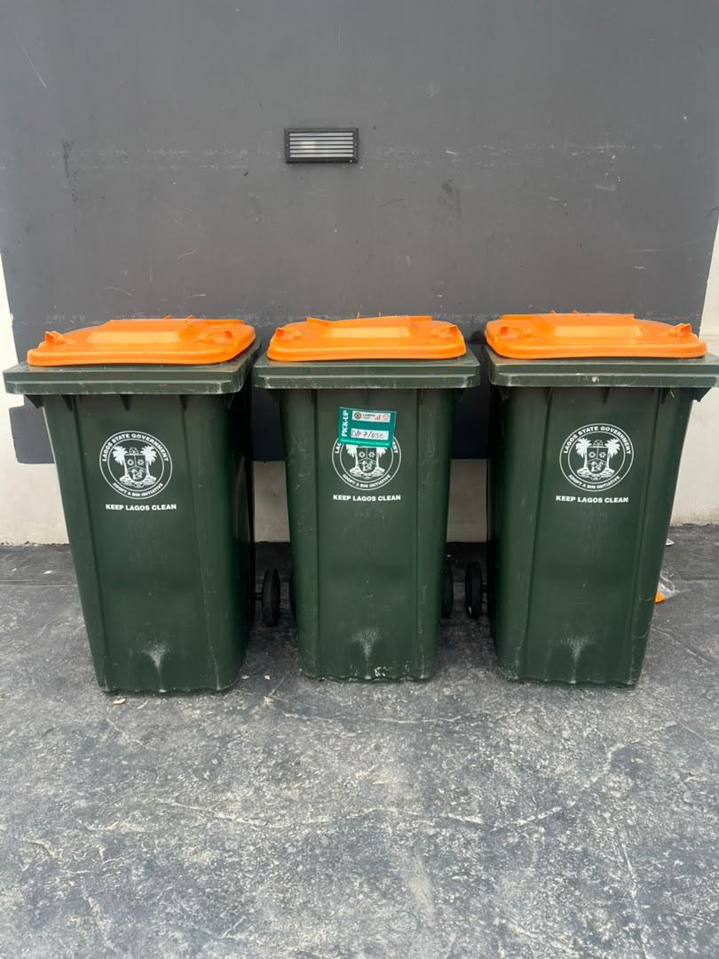
Three Lagos State Government (LAWMA) wheeled bins with orange lids, positioned against the exterior wall. One bin carries an active LAWMA collection/pick-up sticker.

Photo 2 — Large Dumpster-Style Bin
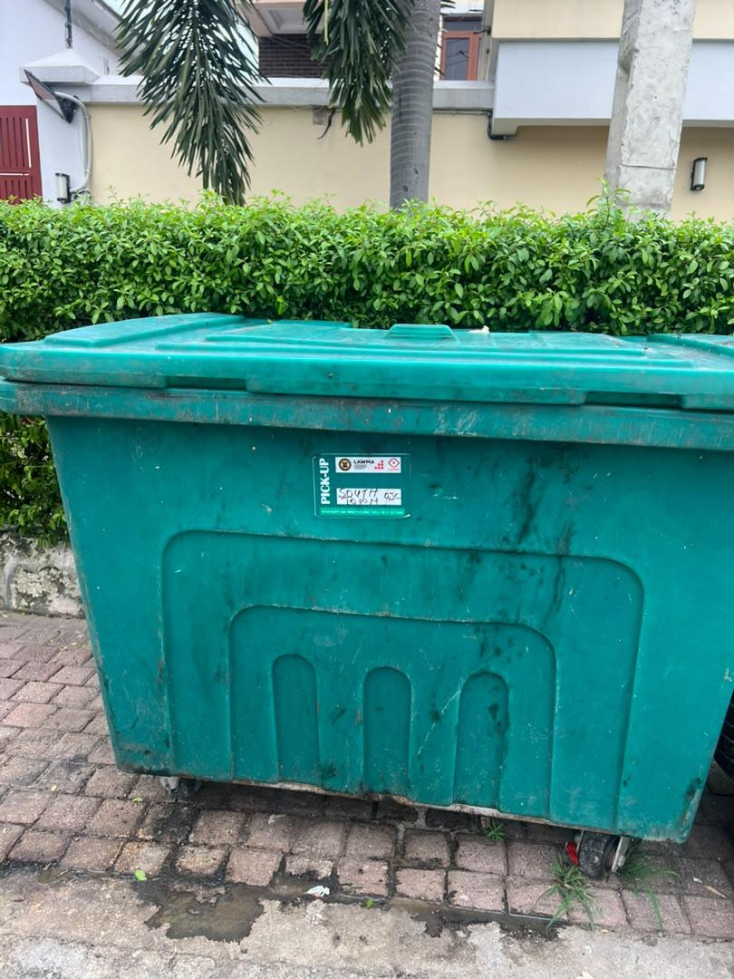
Larger communal LAWMA collection bin, positioned near a hedge/boundary line adjacent to a residential-style building. Bin exterior shows visible surface soiling and staining.

Photo 3 — Wheelie Bin, Rear View
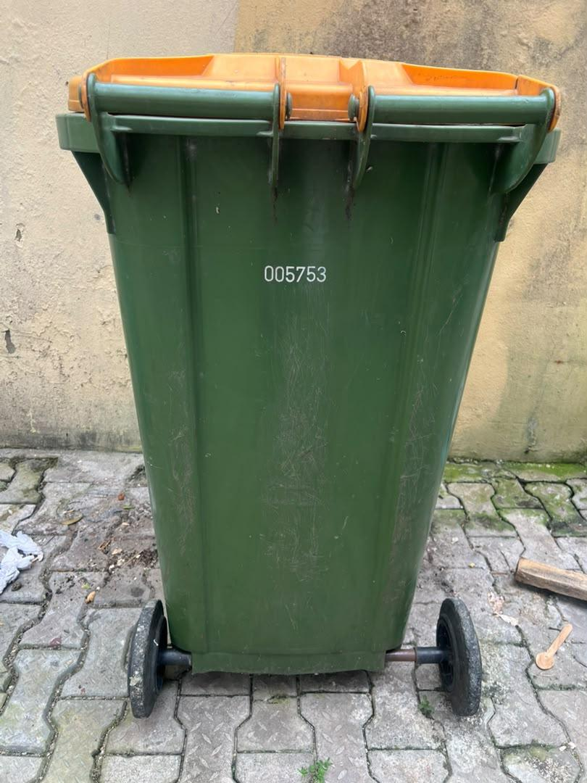
Rear view of a single LAWMA wheelie bin (asset ID 005753) on a paved surface, showing wheel/axle condition and structural integrity.

3.0 Compliance Assessment
OBSERVATION AREA | FINDING | ASSESSMENT
Bin coverage / lids | All bins observed are lidded and wheeled | Satisfactory
Waste collection arrangement | Active LAWMA pick-up stickers visible on two bins, indicating a scheduled municipal collection is in place | Satisfactory
Waste segregation | All bins are uniform, general-purpose municipal bins; no colour-coding or labeling distinguishing general, recyclable, or hazardous/e-waste streams | Gap identified
Bin cleanliness / housekeeping | The large dumpster-style bin (Photo 2) shows notable surface soiling and staining | Gap identified
Bin placement | Large bin positioned close to hedge/vegetation and near a residential-style building boundary | Observation — review for pest/vector and odour risk
Structural condition | Bins appear structurally intact; wheels/axles visibly functional (Photo 3) | Satisfactory

4.0 Findings & Recommendations
KEY GAP
No waste segregation is evident from the external bins photographed — all appear to be general municipal collection bins. Corporate HSE Manual Section 14.0 calls for responsible waste management with due regard to environmental requirements; without internal segregation (general / recyclable / hazardous or e-waste), all office waste streams are currently combined before collection.
- Introduce clearly labeled, colour-coded internal bins at the Lagos Office (e.g., general waste, recyclables, and a separate secure container for e-waste/hazardous office waste such as batteries or toner), feeding into the external LAWMA bins for general waste only.
- Establish a bin-cleaning schedule for the large dumpster-style bin, given the visible soiling in Photo 2 — recommend at minimum a monthly wash-down.
- Review the placement of the large bin relative to the adjacent hedge/vegetation and building boundary, to reduce pest/vector attraction and odour risk, and relocate if a more suitable location is available.
- Confirm that any hazardous or electronic waste (e.g., printer toner, batteries, IT equipment) is routed through a separate, licensed disposal channel rather than general LAWMA municipal collection.

5.0 Managing Director's Endorsement
This Waste Management & Housekeeping Inspection Report for the SWDA Lagos Office, including the findings and recommendations above, is endorsed for action by the Regulatory Compliance Manager and Facilities/Admin.
SIGNED: ______________________________ DATE: ______________
Chief Executive Officer / Managing Director
South West Design Africa Limited (SWDA)

